Lab Assignment #3
Finite Element Simulation Convergence Study

EAE 133 - Finite Element Methods in Structures
Professor N. Sarigul-Klijn
TA: Noah Derita

Aurian Malhotra
920005606
Section A04, 10/15/2025

Introduction
The objective of this lab was to evaluate the convergence behavior of a finite element model representing a linearly tapered aircraft wing under a linearly varying distributed load. The analysis aimed to determine the nodal displacements and axial stresses while refining the beam element mesh from 10 to 80 elements. Using the geometric and loading data provided in Figures 1 and 2 and Table 1, the wing’s cross-sectional properties were defined as scalar functions of the spanwise coordinate x. Each mesh was analyzed in Patran/NASTRAN using linear static analysis to determine the displacement and stress distributions, which were then compared to assess convergence accuracy.

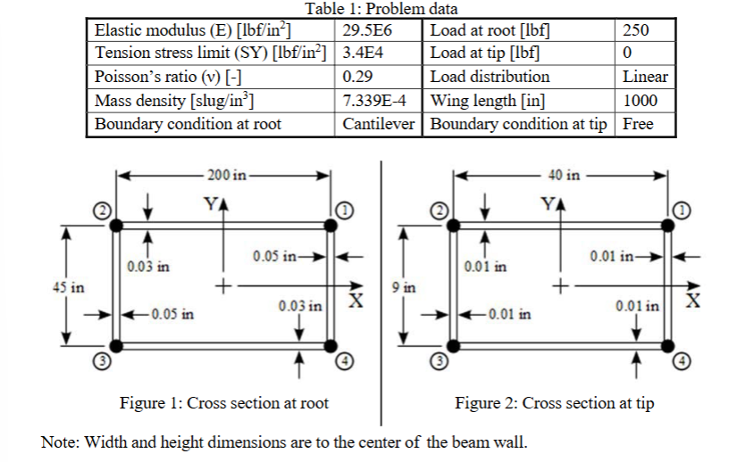

Procedure
The geometry was defined using two nodes at coordinates [0 0 0] and [1000 0 0], connected by a single beam element curve representing the wing span. Cross-sectional properties (width, height, and wall thicknesses) were modeled as linear scalar functions of the spanwise position x, as shown in Figure 3. These functions defined the beam property variation along the length.

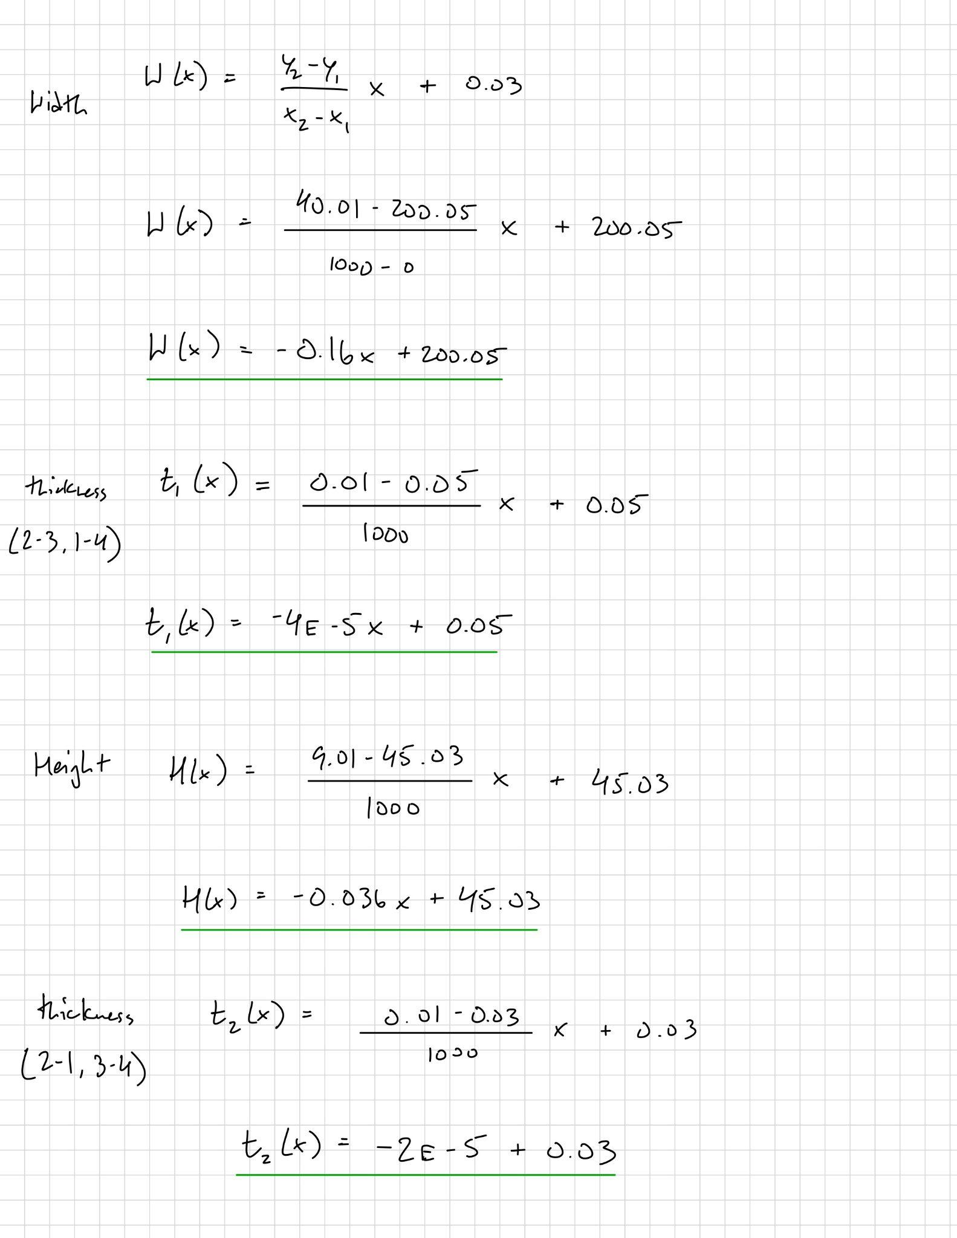
Figure 3: Scalar Functions for linearly tapered aircraft wing

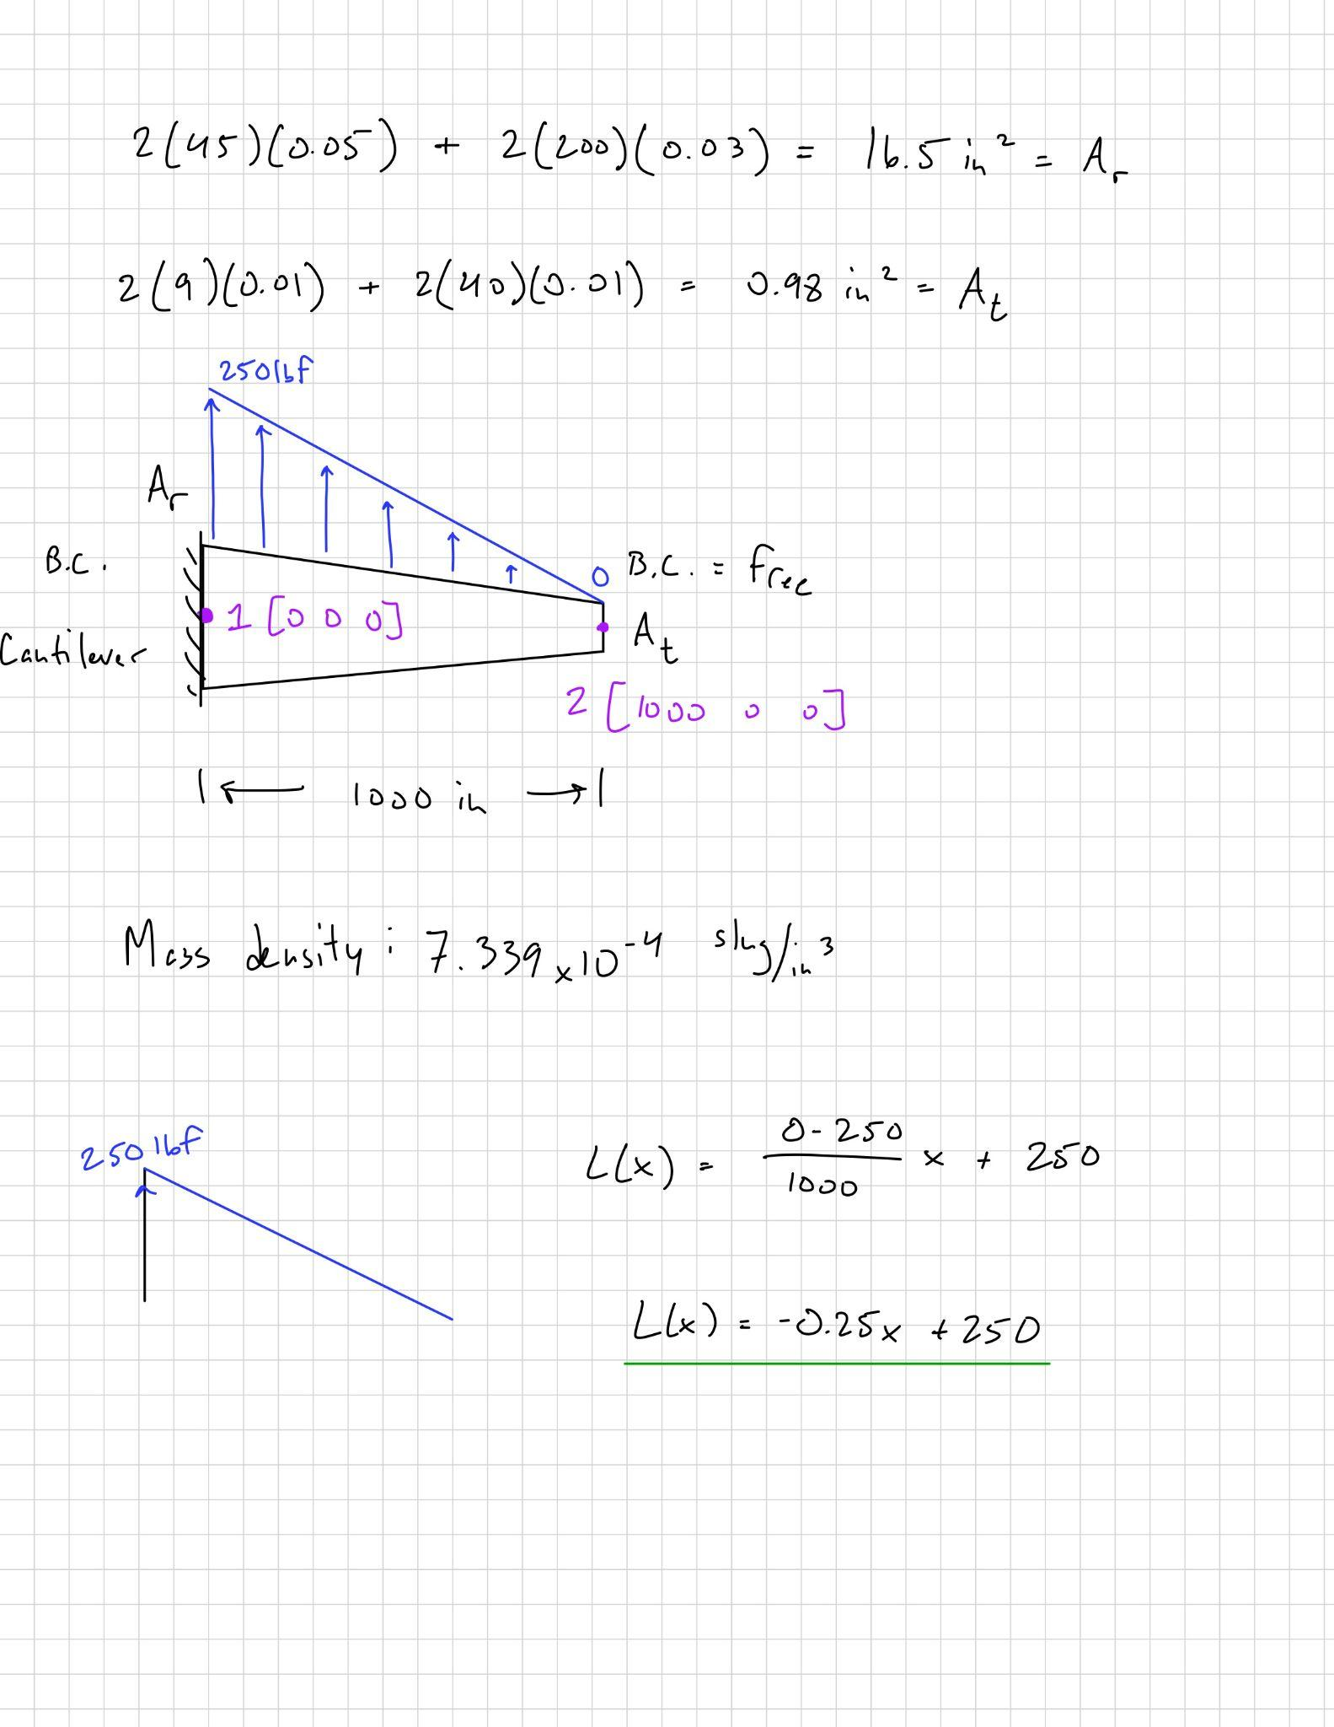
Figure 4: Load Function and Diagram

Material properties from Table 1 were applied, and a cantilever boundary condition was assigned at the root (x = 0). The linearly varying load L(x) shown in Figure 4 was applied in the positive y-direction.

The model was discretized into 10, 20, 40, and 80 beam elements. Each configuration underwent linear static analysis, and the resulting nodal displacements and element stresses were extracted from the .f06 output. For each case, a fringe plot was generated to visualize stress distribution and deformation, with results summarized in Tables 2 and 3 and the convergence plot shown in Figure 6.

Results
The finite element analysis of the tapered aircraft wing was performed using beam elements with 10, 20, 40, and 80 element meshes. Each case was evaluated under a linearly varying distributed load, and the tip deflection and stress distributions were recorded from the .f06 output. The displacement and stress data demonstrate how increasing mesh refinement improves the accuracy and stability of the results.

Figure 5 shows the deformed shape and stress distribution of the 80-element model. The structure exhibits the expected cantilever bending behavior, with maximum stress concentrated at the fixed root and maximum vertical displacement at the free tip.

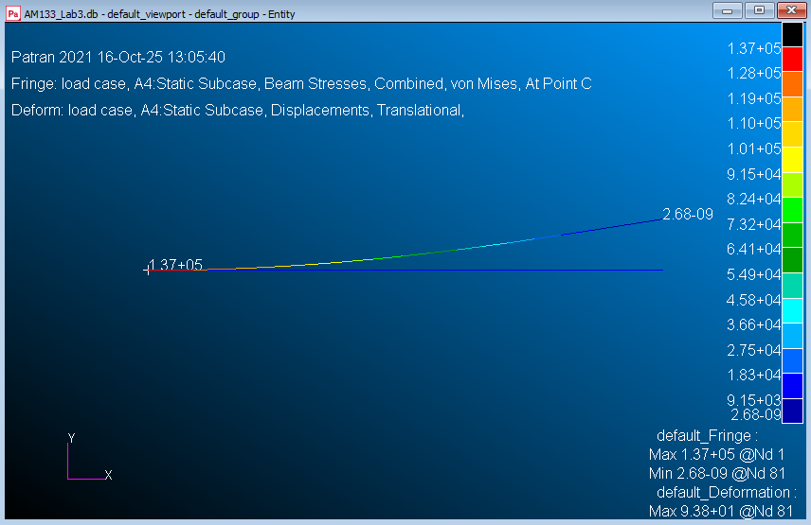
Figure 5: Deformed beam and stress fringe plot for 80-element mesh showing cantilever bending behavior (Patran visualization)

Table 2 summarizes the minimum and maximum displacement vectors for each finite element mesh. The results show that the maximum displacement consistently occurs at the tip of the beam, while the minimum is observed near the root. As the number of elements increases, the tip displacement converges to approximately 93.77 in, indicating that further mesh refinement has minimal effect on the overall displacement field.
Mesh Case  (# of Elements) | Minimum Displacement (Node 2) | Maximum Displacement  (Tip Node)
10 | [0.0, 1.268141, 0.0, 0.0, 0.0, 2.059412E-02] | [0.0, 9.272077E+01, 0.0, 0.0, 0.0, 1.460337E-01] Node 11
20 | [0.0, 3.792217E-01, 0.0, 0.0, 0.0, 1.034895E-02] | [0.0, 9.388304E+01, 0.0, 0.0, 0.0, 1.488801E-01] Node 21
40 | [0.0, 1.251658E-01, 0.0, 0.0, 0.0, 5.171193E-03] | [0.0, 9.379414E+01, 0.0, 0.0, 0.0, 1.484059E-01] Node 41
80 | [0.0, 4.648074E-02, 0.0, 0.0, 0.0, 2.584536E-03] | [0.0, 9.377079E+01, 0.0, 0.0, 0.0, 1.482855E-01] Node 81
Table 2: Maximum/Minimum Nodal Displacements for Each Mesh Case
(x, y, z, Θ_{x}, Θ_{y}, Θ_{z} [in] and [rad])

Table 3 lists the maximum and minimum axial stresses (tensile and compressive) computed from each finite element case. The largest tensile stress occurs at the fixed root, while the smallest compressive stress magnitude occurs at the free tip. The stress values converge to approximately 1.37 × 10⁵ psi, indicating consistent results across all mesh refinements.

Mesh Case  (# of Elements) | |S-Min| (psi)  @ Tip | |S-Max| (psi)  @ Root
10 | 2.260094E-10 | 1.372656E+05
20 | 7.203766E-10 | 1.374372E+05
40 | 8.188344E-09 | 1.373085E+05
80 | 2.677034E-09 | 1.372763E+05
Table 3: Maximum/Minimum Stresses for Each Finite Element Case

Figure 6 presents the convergence plot of maximum tip displacement versus number of elements. The curve clearly approaches a stable value near 93.77 in, confirming that a mesh of 40 to 80 elements is sufficient for this analysis.
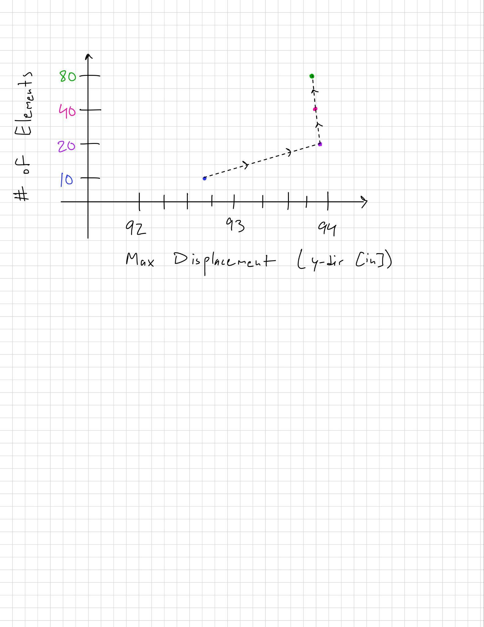
Figure 6: Convergence Plot - Maximum Displacement v. Number of Elements

Discussion and Conclusion
The results confirm the expected behavior of a cantilevered tapered beam under a distributed load. The maximum deflection occurs at the free tip and the maximum stresses occur at the fixed root. The axial stress distribution along the beam shows that increasing the mesh count does not significantly affect the stress magnitude. The stress converges to approximately ±1.37 × 10⁵ psi, remaining below the yield stress limit SY = 3.4E+04 lbf/in² specified for this problem. Therefore, the safety factor is approximately $\frac{1.37 x {10}^{5}}{3.4 x {10}^{4}} ≅ 4.0$, indicating the beam is operating within elastic limits.

The displacement convergence is clearly observed in the tip deflection values, which stabilize around 93.77 in for the 40 and 80 element cases. This demonstrates that the finite element mesh is sufficiently refined, and further discretization would produce negligible change in results. The linear relationship between displacement and load direction also supports the assumption of linear static behavior.

Overall, the analysis successfully validated the finite element convergence process. With increasing mesh refinement, both the stress and displacement results approached stable, physically realistic values consistent with theoretical expectations for a linearly tapered cantilever beam.

